Posted to the ITIC Tsunami Bulletin Board 18 March 2011
SHUTO Nobuo
Disaster Control Research Center
Tohoku University
Email : shuto.nobuo@gmail.com

Attached are Airphotos showing the flooded areas by the 2011 tsunami at Reido and Bougasawa, in the Bay of Yamada, Iwate Prefecture, and maps that show the areas flooded by the 1933 Showa Great Sanriku Tsunami (solid line), the Meiji Great Sanriku Tsunami (dashed dotted line) and the 1611 Keicho Tsunami (dashed double-doted line). The last one was drawn by Prof. A. Imamura after the 1933 tsunami, based upon local legend.

Aerial: 2011 tsunami, Reido
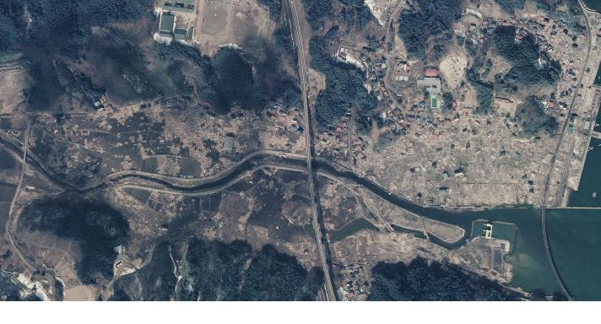
1933 (solid), 1896 Meiji Great Sanriku (dashed dotted), 1611 Keicho (dashed double-dotted line):
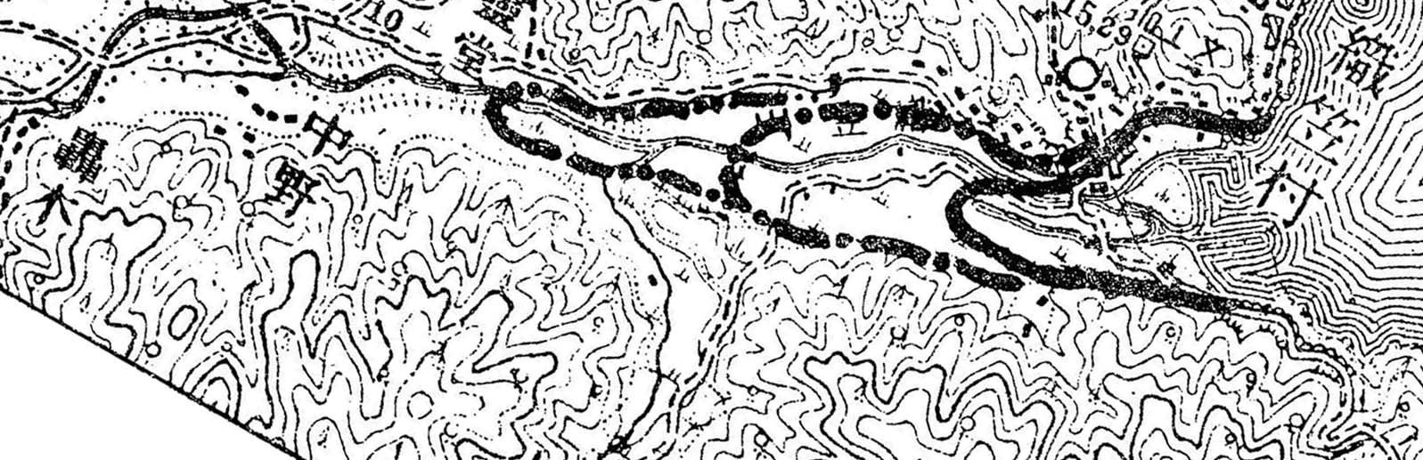

Aerial: 2011 tsunami, Bougasawa

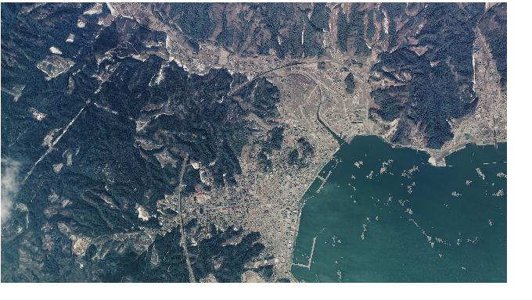

1933 (solid), 1896 Meiji Great Sanriku (dashed dotted), 1611 Keicho (dashed double-dotted line):

